# **Sir Syed University of Engineering & Technology (SSUET)**

# **Software Engineering Department**

***Course Name: Artificial Intelligence (SWE-314L)***

***Semester: 5th***

***Batch: 2020F***

***Section: “E”***

**PROJECT REPORT**

***Project Title: FACE DETECTION ATTENDANCE SYSTEM***



***Submitted To:***

***Engr. M. Naseem***

***Engr. Farheen Qazi***

***Engr. Samrah Shafiq***

***Submitted By:***

**ADNAN ASAD 2020F-SE-249**

**MAHAM FATIMA 2020F-SE-211**

**RIDA BHATTI 2020F-SE-217**

**TABLE OF CONTENTS**

|  |  |  |
| --- | --- | --- |
| S. No. | TOPICS | PAGE No. |
| 1 | PROBLEM DOMAIN |  |
| 2 | PROPOSED TREATMENT |  |
| 3 | PLAN OF WORK |  |
| 4 | PROJECT SCHEDULING |  |
| 5 | SOFTWARE AND HARDWARE SPECIFICATIONS |  |
| 6 | BLOCK DIAGRAM |  |
| 7 | SYSTEM FLOW DIAGRAM |  |
| 8 | USER GUIDE |  |

**TEAM PROFILE**

1. **ADNAN ASAD (2020-SE-240)**
2. **MAHAM FATIMA (2020-SE-211)**
3. **RIDA BHATTI (2020-SE-217)**

**CONTRIBUTION OF TEAM MEMBERS:**

|  |  |  |  |  |
| --- | --- | --- | --- | --- |
| TASK | ADNAN ASAD | MAHAM FATIMA | RIDA BHATTI | TASK TOTAL |
| Search & acquire components | 40% | 30% | 30% | 100% |
| Design Subsystems | 50% | 25% | 25% | 100% |
| Write Reports | 25% | 50% | 25% | 100% |
| Presentations | 25% | 25% | 50% | 100% |

## **PROBLEM DOMAIN**

**Project Objective:**

Attendance is prime important for both the teacher and student of an educational organization. So it is very important to keep record of the attendance. The problem arises when we think about the traditional process of taking attendance in class room. Calling name or roll number of the student for attendance is not only a problem of time consumption but also it needs energy. So an automatic attendance system can solve all above problems. There are some automatic attendances making system which are currently used by much institution. One of such system is biometric technique and RFID system. Although it is automatic and a step ahead of traditional method it fails to meet the time constraint. The student has to wait in queue for giving attendance, which is time taking.

This project introduces an involuntary attendance marking system, devoid of any kind of interference with the normal teaching procedure. The system can be also implemented during exam sessions or in other teaching activities where attendance is highly essential. This system eliminates classical student identification such as calling name of the student, or checking respective identification cards of the student, which can not only interfere with the ongoing teaching process, but also can be stressful for students during examination sessions. In addition, the students have to register in the database to be recognized. The enrolment can be done on the spot through the user-friendly interface.

**Project background:**

In the face detection and recognition system, the process flow is initiated by being able to detect the facial features from a camera or a picture store in a memory. The algorithm processes the image captured and identifies the number of faces in the image by analyzing from the learned pattern and compare them to filter out the rest. This image processing uses multiple algorithm that takes facial features and compare them with known database.

The motivation behind this project is to simplify the means by which attendance is taken during lectures and how much time it takes. The use of ID cards or manually calling out attendance and writing it down on sheets is not productive and efficient. This system will detect the number of faces on the class and will also identify them from the store database. With the face detection and recognition system in place, it will be easy to tell if a student is actually present in the classroom or not.

**Aims and Objectives:** The objective of this project is to develop face recognition attendance system. Expected achievements in order to fulfill the objectives are:

● To detect the face segment from the video frame.

● To extract the useful features from the face detected.

● To classify the features in order to recognize the face detected.

● To record the attendance of the identified student

**Project Specifications:**

* Uses Pattern Matching algorithm for face detection.
* Score of minimum 600 required to perfectly match a face.
* Metric: Camera Resolution.
* For prototype fixed to 10 users only but scalable design.
* Requires good lighting condition for better camera capture capability.

**Problem Statement**:

Traditional student attendance marking technique is often facing a lot of trouble. The face recognition student attendance system emphasizes its simplicity by eliminating classical student attendance marking technique such as 5 calling student names or checking respective identification cards. There are not only disturbing the teaching process but also causes distraction for students during exam sessions. Apart from calling names, attendance sheet is passed around the classroom during the lecture sessions. The lecture class especially the class with a large number of students might find it difficult to have the attendance sheet being passed around the class. Thus, face recognition attendance system is proposed in order to replace the manual signing of the presence of students which are burdensome and causes students get distracted in order to sign for their attendance. Furthermore, the face recognition based automated student attendance system able to overcome the problem of fraudulent approach and lecturers does not have to count the number of students several times to ensure the presence of the students.

Hence, there is a need to develop a real time operating student attendance system which means the identification process must be done within defined time constraints to prevent omission. The extracted features from facial images which represent the identity of the students have to be consistent towards a change in background, illumination, pose and expression. High accuracy and fast computation time will be 6 the evaluation points of the performance.

**Scope of the project:**

The second module is a desktop application that does face recognition of the captured images (faces) in the file, marks the students register and then stores the results in a database for future analysis.

## **2.PROPOSED TREATMENT**

## The system will be presented an image either via camera or from memory and it must detect the number of faces on it automatically. After identifying faces, the system should crop the faces from the image and store them in memory for image recognition which will be done in the second step. The system should be able to automatically count the number of faces detected on the image. The second step will be the recognition part where the system will be able to match faces from the stored dataset and compare it to the input data from the first step. A software will be used for this system which automatically sorts out the faces. The software will be inter-active so to facilitate interaction between multiple tasks as required. Because the system has two steps, the second phase of the system will involve the training of images on a dataset that are to be used for recognition.

## 1. Reducing time wastage during conventional class attendance.

## 2. Utilizing latest trends in machine vision to implement a feasible solution for class attendance system.

## 3. Automating the whole process so that we have digital environment.

## 4. Preventing fake roll calls as one to one attendance marking is possible only.

## 5. Encouraging the use of technology in daily lives.

## **3. PLAN OF WORK**

Firstly we make a project Scheduling in which we start from Study and learn from labs, Search about topic, Practice and start building the code, Writing code to recognize the face, Review and correct mistakes, Test the code functionality, Prepare project Video, Prepare project report, Prepare the poster and Test the whole system. We divided the projects in many chunks and then combine the whole project together with cooperation off all team members

## **4. PROJECT SCHEDULING**



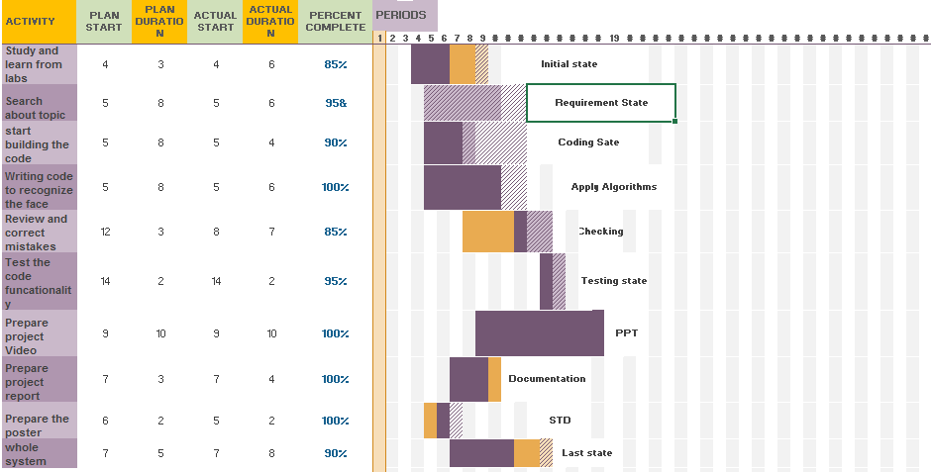

**SOFTWARE AND HARDWARE SPECIFICATIONS**

## **Hardware Requirements:**

## Memory (RAM): Minimum 4GB Sound card w/speakers

* Camera 8mp

**Software Requirements:**

* Python 3.10

**Software Implementation:**

**OpenCV:**

We used OpenCV 3 dependency for python 3.10. Open Cv is library where there are lots of image processing functions are available. This is very useful library for image processing. Even one can get expected outcome without writing a single code. The library is cross-platform and free for use under the open-source BSD license. Example of some supported functions are given bellow:

● Derivation: Gradient/Laplacian computing, contours delimitation

● Hough transforms: lines, segments, circles, and geometrical shapes detection 24

● Histograms: computing, equalization, and object localization with back projection algorithm

● Segmentation: thresholding, distance transform, foreground/background detection, watershed segmentation

● Filtering: linear and nonlinear filters, morphological operations

● Cascade detectors: detection of face, eye, car plates

● Interest points: detection and matching

● Video processing: optical flow, background subtraction, camshaft (object tracking)

● Photography: panoramas realization, high definition imaging (HDR), image inpainting

**Csv:**

Csv file is used in the project were the attendace is marked and save all the records and the data

**Jpg:**

Jgp images more then 70+

**Algorithm apply:**

1) Haar like Cascade

2) Local Binary Pattern Histogram(LBPH)

## **6. BLOCK DIAGRAM**

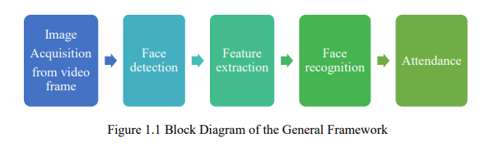



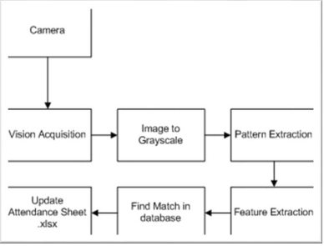

## **7. SYSTEM FLOW DIAGRAM**

**Simple Flow Diagram**

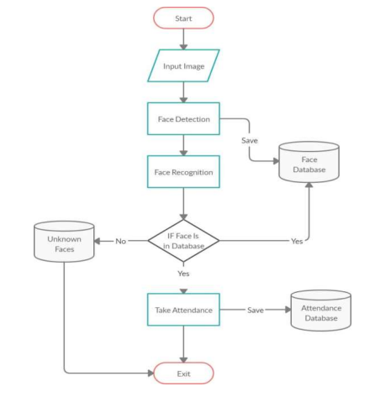

**Detailed Flow Diagram**

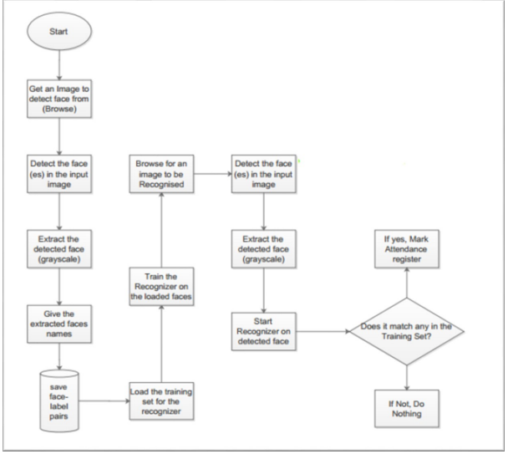

## **8. USER GUIDE**

## **1. Main Window**

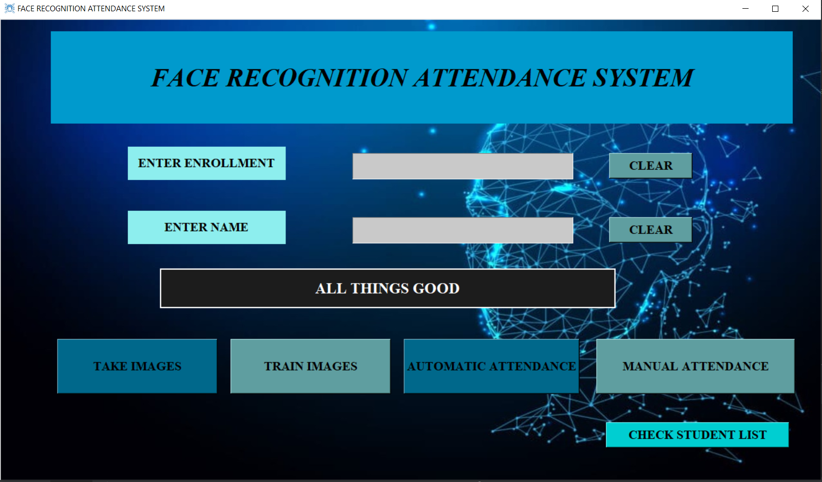

## **2. Subject and Time duration window for attendance**

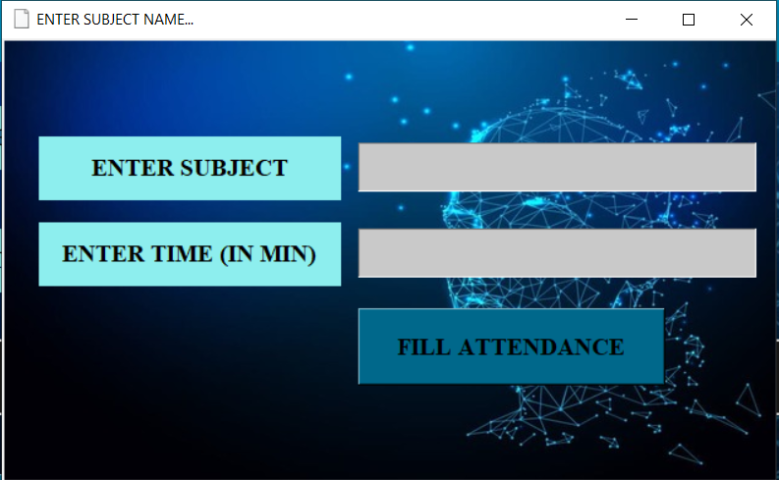

## **3. Attendance marked student list**

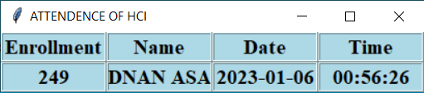

## **4. Manual attendance window**

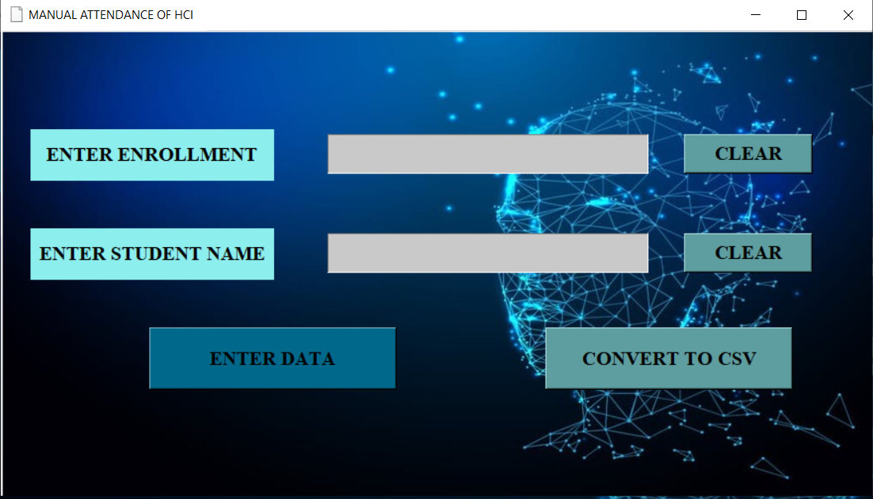

## **5. Login window for admin to get all student registered**

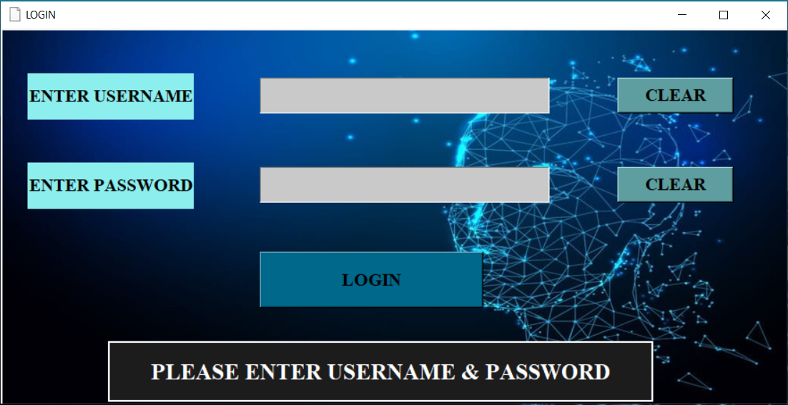

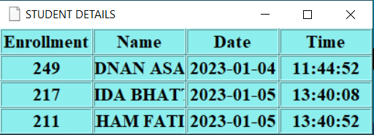

## **REFERENCES**

Include all references here.

## INSTRUCTIONS

1. You have to implement AI based algorithms or libraries in your project.
2. Try to implement the project on your own, must not be cheat or copy from anywhere and must believe that you will achieve the target!
3. The font size should be 14 for heading and 12 for the rest of text, font style should be Times New Roman. The font color should be black only.
4. The header must contain the heading “Artificial Intelligence Project Report” in the middle and the footer must contain the heading “SIR SYED UNIVERSITY OF ENGINEERING AND TECHNOLOGY” on left side and page numbers on the right side through out in the report. The page number should start from “Problem Domain”.
5. There can be only single line spacing between the lines.